WORKSHEET FOR ROMAN BATHS MUSEUM **Name ……………………………………………**

**As you walk round the museum, try to ‘think yourself’ into the character of one of the people we know visited the Temple and Baths in Roman times, or a friend of theirs. You can find details of people whose names appear on the inscribed stones which are on display – translated on a sheet which can be downloaded from the museum’s website**

http://www.romanbaths.co.uk/learning/schools.aspx

You can also download a copy of the Tombstone and Altar Decoding leaflets, which show you how to interpret the writing on the stones for yourself rather than relying on translations.

***……………………………………………………………………………………………………………………………………………….***

The questions below are intended as a guide for your own notes.

*After your visit you can make a poster, a booklet, a Powerpoint presentation or a webpage.*

*You will need to include the following:*

**1. What is your reason for coming to the temple and baths?**

*e.g. worshipping the goddess and asking her to do something for you; asking for a cure for an illness and then hoping that bathing in the sacred water will help; dedicating an altar to Sulis Minerva or another deity; visiting the temple and then relaxing in the Baths with your friends.*

**2. What do you see in different areas? Describe or draw:**

**the Temple courtyard with the temple in front of you**

**the sacred spring**

**different rooms in the Baths, including the swimming pool**

*The museum’s models and videos will help you to visualise this and your visit to the museum will start with a view looking down at the Great Bath, the Roman swimming pool which originally had a vaulted roof over it.*

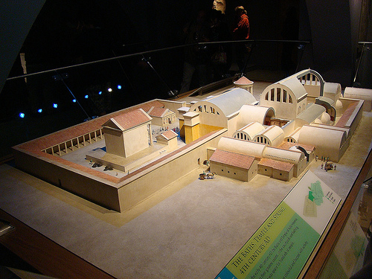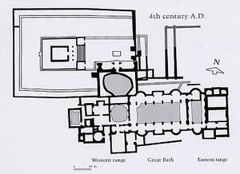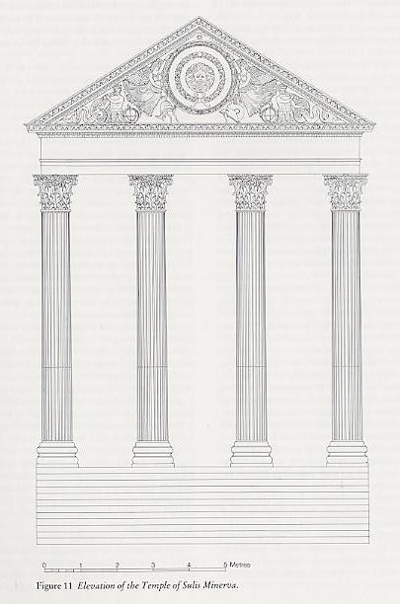

**The model and plan show the back of the temple precinct with the Baths on the right Temple facade**

**and the sacred spring with its vaulted roof connecting the two areas.**

**3. What are you and your friends wearing? What do you talk about? Refer to any items in the museum which are relevant to your daily routine or your home life.**

*You will need to make notes for this section whenever you see e.g. items used by Roman soldiers, jewellery, portrait-carvings of people, pottery, glassware, farming or industrial items, coins, mosaics – in fact anything you like which shows you how people lived in Roman times and what was important to them!*

*You can also get an idea of how they felt when someone stole something from them if you look at the Curses displays.*

**4. What are your feelings about the goddess Sulis Minerva and the other gods and goddesses worshipped at Aquae Sulis?**

**5. Which of the inscribed stones (a votive altar or tombstone) is significant for your character? Find it and sketch it.** You may also wish to include one of the curses.

N.B. Tombstones were not erected inside this area, but you might decide to use a person whose tombstone has been found nearby, someone who regularly enjoyed visiting the Baths.

*Even if you are not a brilliant artist, it is important to attempt a drawing because you will examine the artefact very closely and find out more about it.*

**6. Why do you enjoy your relaxing visit to the Baths?** You have brought your own strigil and massage oil. You will chat to your friends as you enjoy the warm rooms, the cold plunge and the swimming pool, and you will hope that your clothes don’t get stolen! You will be proud of the impressive buildings and the sophisticated design and engineering of the water courses.

*…………………………………………………………………………………………………………………………………………………*

WHERE TO FIND THE INSCRIBED STONES

*Your character can be anyone mentioned in an inscription or their friend, family member, slave or freedman/freedwoman.*

***‘Meet the Romans’*** is the first section, where you can see a carving of an un-named man wearing a toga.

***‘Life and Death in Aquae Sulis’*** contains information about

1. Soldiers :

Lucius Vitellius Tancinus, a cavalryman from Spain

Iulius Vitalis an armourer in the 20th Legion

Antigonus, a retired soldier from the 20th Legion

Gaius Curiatius Saturninus, a centurion of the 2nd Legion

2. Women - as well as a carving of a lady’s head showing her very ornate hairstyle :

Mercatilla, a very young freedwoman (ex-slave)

Rusonia Aventina from Metz in France

3. a Stonemason

Priscus from Chartres in France, which was a stone-working area like Bath

NB Another stonemason, Sulinus, is commemorated in a reconstruction of his workshop near the entrance to the Great Bath.

*Perhaps these two were advertising their business by carving inscriptions at Bath!*

***‘Worshipping the Gods’*** contains information about

1. a priest

Gaius Calpurnius Receptus, whose tombstone inscription was organised by his freedwoman-wife Calpurnia Trifosa

2. people who dedicated inscribed altars to Sulis Minerva or other gods and goddesses

Sulinus

Peregrinus from Trier in Germany

Aufidius Lemnus and Aufidius Eutuches, freedmen of the centurion Marcus Aufidius Maximus, both dedicated an altar asking for their ex-master to be kept safe

Vettius Benignus, a freedman, dedicated an altar to Diana the goddess of hunting

***‘The Temple Courtyard’*** is a very prestigious location : the main sacrificial altar was in the open air in front of the temple and this was where the Haruspex Lucius Marcius Memor, a very important Roman priest, displayed the dedication stone which accompanied his statue of Sulis Minerva.